Anatomy of a Successful Parish Wide Study--Tips from one parish
Mark Tristani 2-19-18
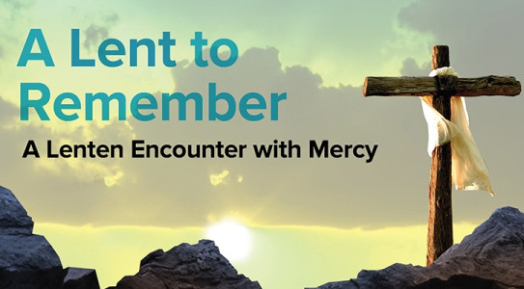
I am just so excited about the success of the “A Lent to Remember” Parish Study that we just kicked off last night at my home parish! I was going to be happy with 30 attendees, but our Lord had bigger plans! We had 86! Imagine my joy as we were rolling out extra tables and chairs to accommodate!
Here are some of the things that I think made this a successful launch:
- Identify at least 2-3 people to help with the program planning and preparation. This is not a 1 man/woman job.
- Pulpit Announcement after each mass with zeal and excitement for the program.
- Two weeks of signups. We asked for phone and email contact info.
- Follow on announcements (read, not pulpit) after each mass.
- Sunday night at 7pm. It is always difficult to find a day/time that works for everyone. Sunday night turned out to be a good night since there would be little sports or school activities then.
- Contacting each attendee on Friday before program - Email blast to all and phone to those without email.
- Start the program with Praise and Worship. We asked the Music Ministry to help here. They were very happy to do this. Three Praise and Worship songs, with lyrics printed off and handed out so all could sing along. Ask people to stand for this. Everyone really entered in and this set the tone for the evening.
- Emcee for the evening. You need someone to lead the program, with joy and excitement. Welcoming. Encouraging. Keep the night on track.
- Pray for the program in advance and ask others to do the same
- Sprinkle holy water around the program space and pray while doing so for the Holy Spirit to be present and for St Michael to defend the evening against the evil one who you know is not happy with what we are trying to do here.
- Hospitality (snacks/drinks). Our parish covered the first night and we asked people to sign up to bring snacks for the next three sessions.
- Encourage mingling before and after the program. The goal of this program is both Faith Formation and Fellowship. Everyone craves good relationships and the Fellowship part is key to getting people to return and to tell others about the program.
- Giveaway – we put a post-it under one person’s chair for a small give-away. We are planning to do that for each session.
- Room decoration – set the tone with a welcoming environment. Table center piece if possible, i.e., mints, candy, or flowers
- FORMED “business cards” – we used this as an opportunity to re-teach the parish on FORMED; how to access and what content is there. Will demo FORMED after one of the sessions.
- Open and close the program with prayer.
- Feedback sheets. At the end of the study be sure to have a questionnaire for participants to complete. What did they like? Where could we do better next time? What topics would you be interested in for the next Parish Study. Will you attend? Will you invite someone and help spread the word?
- Keep the momentum going with a second Parish Study. Start planning once this study completes.

Key documents from the FORMED Leaders Website (https://leaders.formed.org/)

Parish-wide Studies, How to Host a Parish Wide Study: https://leaders.formed.org/pr_2/
Why Run a Parish-Wide Study: http://leaders.formed.org/wp-content/uploads/2017/07/HowToRunAParishWideStudy.pdf
General Promotional Resources: https://leaders.formed.org/promo_resources/
Promotional Resources for any Study: https://leaders.formed.org/pr_2/

